Document Type: Final Report
Revision Number: 5.0
Project Name: HUEXT
Sample Only
This document was submitted by students in a previous class. Their requirements were different from yours. We offer it only as a sample of what a project was for that class. Copying this document, in whole or in part, and submitting the result as your own work, would be a violation of the honor code.

1. Problem statement and approach
The onset of troubled economic times raises questions about how changes in our markets affects everything in our environment. In particular we have focused our effort on the issues that Universities will face as a result of a change in the economy. In order to make inferences about the economic state and its affect on the financial stability of higher education, we chose to break down the inputs and outputs of one school to begin this process. We choose Harvard University Extension School as our subject. The goal is to forecast what changes will be necessary for Harvard University Extension School to make depending on the state of the economy. This means things like forecasting classroom size, breadth of class offerings, number of faculty and staff required to support this.

2. Description of Scenarios
We are comparing two scenarios. The first willl be the case where the economy is doing poorly. What we hope to discover is that enrollment will increase as people begin to lose work and attempt to seek new skill sets. We also expect that this result in a decrease in specialized courses and greater enrollment in more generalized course. This would also be limited by the amount and size of classes available as well as the number of faculty available to teach these courses. We will be taking all these factors into consideration when making developing our model. The model will show the most efficient configuration for the Harvard University Extension School to hold in this scenario.
See Figure 1.1 First Scenario Estimate (Weak Economy)
The first stage of the model, the EnrollmentAnalysis worksheet examines enrollment at the Harvard University Extension School taking into account a sample size of 10 courses that span the spectrum typical classes offered at the Harvard University Extension School. The model breaks down the quantity of the people enrolled in the Harvard University Extension School and distributes those students into each course using a predetermined percentage parameter. Then with the addition of the static parameters of fee, semesters and tuition costs, the model forecasts the enrollment levels over the twelve periods. This allows us to determine the revenues stream from enrollments.
The ClassAnalysis worksheet takes the enrollment stream and uses it to determine the physical space needs for each semester. This takes the fixed assets of the Harvard University Extension School into account when trying to fill the classroom with courses from each one of the class categories. This is then later brought back in to calculate the infrastructure cost stream.
The StaffAnalysis worksheet is where we estimate the amount of staff needed to accommodate the influx of students enrolling. The model takes into account the infrastructure capacity. Once the quantity of each type of employee is determine the model then replicates what the hiring schedules will be for the twelve periods. The model then calculates the total overhead cost of staffing the Harvard University Extension School.
The InfraAnalysis worksheet is the stage where the model takes in the figures from the previous two tabs to crunch the numbers on the total infrastructure costs for the whole Harvard University Extension School. This takes into account the operational cost such as student fees, library fees, administration, and overhead for the rooms. These totals are reflected as overhead costs that will pull down overall revenues.
Finally the RevenueAnalysis worksheet uses all the streams calculated previously and applies more dynamic formulas that make a total revenue determination. These determinations along with the other two streams are represented graphically in Figure 1.2 in Appendix A.
Scenario two will take a look at everything from the opposite prospective. We will examine the Universities situation when faced with an economy that is doing well. The hypothesis here is that since there will be less unemployment and more stability, the Harvard University Extension School will experience a decrease in enrollment in general. Also we think that we will find that they type of course that students enroll in will change as well. Except in this situation students will enroll in more specialized courses design to refine the skill that are using in the work place. This means that we would then see a decrease in enrollment of the more general courses.
Fiigure 1.2 Second Scenoario Estimate (Strong Economy)
Scenario two has inputs that are very similar to scenario one with some exceptions. When determining what inputs to modify we based our decisions on the assumptions mention in the previous paragraph and attempted to simulate this in our model. The important thing to note is that our parameters did not need to change in order for the model to produce the desired results. All we modified was our inputs. As the control of the study we mantained the same sample size of enrollment semesters and periods, allowing us to compare apples to apples. We then changed the distribution of the courses enrollment in order to see if changing the balance of enrolled students would ultimately have and effect on the overall revenue stream.
The main inputs that had significant changes were the rates. The enrollment rates were adjusted to reflect a decrease over time. Since economic effects take place over time it made sense to represent that across the twelve periods. Withdrawal rates were adjusted to show an increase over time as we believe there would be more students leaving higher education to persue job opertunities. These rates are wrapped into formulas that will have exponetial impact on revenue and salary for the Harvard University Extension School. The third rate that is effected is the graduation rate projected. The model in this instance will naturally have less graduations over time as less students stay for there whole term.
Another input consideration was the class room size distribution. We viewed this input for the purposes of this comparison a static parameter. Keeping these numbers fixed helps us draw a more acurate comparison against scenario one. In addtion we kept the fee the sames using the same reasoning.
Additional adjustments were made for tution. In this scenario as revenues are lost tution must go up to accomidate that loss. So tuition is adjusted over the twelve periods as well as salaries. As revenues drop tuition rises and salaries drop to compensate. This way the result that spans the twelve periods makes the negative changes less impactful.
Scenario two also had some small increases in fees for insfrastructure to stick with the assumptions of the scenario. This allows our model to show how infrustructure data effects ovarall revenue performance. It is important to note that our model interconnects all these aspects of doing business when diriving it’s output.

3. Conclusions of the Study
Scenario one of our model represents the outcome of Total Salary, Total Infrastructure Costs, Total Revenue and ultimately Total Earnings in the event of a poor economy. We derived these numbers from inputs like fees and enrollment projections that also included parameters such as enrollment distribution, class size, base salary, infrastructure costs, and enrollment capacity. Based on the projections that our model developed, it appears that our original estimations were way off.
The constant increase in enrollment revenues grew steadily keeping the total revenue stream in a positive trend over the twelve periods. The infrastructure cost grew steadily but did not spike as we estimated it would in the beginning. In our original estimation we did not anticipate that our infrastructure stream would be so flat. In the final few quarter all the output have a similar positive trends as our estimate but no extreme variations as we originally projected.
The model shows us that even with aggressive enrollment growth the need for infrastructure spending turns out not to be as vital as we first anticipated. This show us that having the ability to look at class room allocation in an efficient way can really make a huge difference in whether the Harvard University Extension School needs to pay and expand its facilities. If this were a real life scenario, this model potential could save the Harvard University Extension School hundreds of thousands by refining the infrastructure piece to tighten up classroom allocation.
Figure 2.1 First Scenario Actual (Weak Economy)
The second scenario was a little closer to our original estimate. Even though we predicted that total revenue would decline slowly, this did not happen until the 7th period. Our model predicted steady growth in infrastructure cost and salary. Surprisingly the salary expenses and infrastructure cost began to take a dive after the 7th period as well. The trend that the model produced raised flags in our mind that the mix of inputs that we enter were not going to fair well for the Harvard University Extension School if it carried them out in a strong economy. It appears that if this plan were implemented beyond 12 periods the Harvard University Extension School would be in the red shortly there after.
The main concern in scenario two is not the infrastructure costs like in scenario one, but rather total revenues. The key to getting it right in scenario two is finding the correct mix of inputs that allow you to maximize revenue with out putting the Harvard University Extension School out of business in the long term. This would normally be incredible complex but our model makes it easier to test various iterations and quickly identify what will be the most effective solution.
Figure 2.2 First Scenario Actual (Strong Economy)
To conclude our finds have shown us a silver lining to poor economic status. We have successfully proven that the change in economic climate affects the Harvard University Extension School system. Based on our model we have seen that revenue streams will continue to increase even when the economy is poor. Overall earning will be in the black and growing impressively all the way up to twelve periods with a trend that would indicate its continuation beyond the twelve periods.
Sadly a good economic state provided the model with a difficult task of balancing expense and revenue streams that ultimately trended downwards. Earning over time would be negative and service levels would eventually have to be readjusted to compensate of losses. Fortunately the economy is always fluctuating. Our advices to Harvard University Extension School would be to leverage the surpluses of the weak economic periods to assist during periods of economic recovery. Building a reserve just makes good sense when dealing with market volatility.

4. Budget and Schedule Performance
(Time Projected)/(Actual Time Used)
October 16, 2008(2hr)/(2hr)
Tasks/Deliverables:
- Define project team’s goal - Pull together all the functionalities taught over the course of the term into a successful final project and receiving A grade.
- Clarify project topic – Model the impact of a good and bad economy on a school like Harvard University Extension School.
- Create a communication and documentation repository strategy – Use Google Groups.
- Define a checklist of requirements for all six elements of the final project
- Create a draft of the Proposal elements to be circulated between the team
Milestone:
- Kickoff Phase complete / Proposal Phase begins
October 18, 2008(2hr)/(1hr)
Deliverable:
- Final checklist for Course Project Proposal created
- Draft of Course Project Proposal created
October 23, 2008 (3hr)/(2hr)
Tasks/Deliverables:
- Course Project Proposal (deliverable)
Milestone:
- Proposal Phase complete / Development Phase begins
October 30, 2008 (2hr)/(0hr)
Tasks/Deliverables:
- Draft of model created
November 6, 2008 (4hr)/(2hr)
Tasks/Deliverables:
- 2nd Draft of model created
- 1st Draft Midpoint Status Report
November 13, 2008(1hr)/(2hr)
Tasks/Deliverables:
- Submission of Midpoint Status Report (deliverable)
Milestone:
- Midpoint of Project and midpoint Development Phase
January 8, 2009(6hr)/(3hr)
Tasks/Deliverables:
- Drafts for team review: Final Report, Reference Guide, User Guide, and Project Model
Milestone:
- Development Phase complete / Completion and Review Phase begins
January 15, 2009 (3hr)(8hr)
Tasks/Deliverables:
      - Final submission: Final Report, Reference Guide, User Guide, and Project Model (deliverables)
Milestone:
- Completion and Review Phase complete

Totals: (23hr)/(20hr)

We tried our best to adhere to the schedule and set goals that were ambitious in the beginning in an attempt to have the project complete early. As things progressed we found that many of the deliverable’s deadlines were what instilled the sense of urgency in us, and not so much the goals that were set. Also there were several holidays that interrupted this process along the way that created bottleneck of work in the week before they holiday and even somewhat in the week after them.

Overall we saw that it actually took 20 hours as apposed to the 23 hours we projected. What we thought was ambitious numbers was actually pretty much dead on. During this project we spent the majority of our time collectively discussing the structure of the model and trying to come to consensus on what the inputs and outputs of the project should be. In the end after the models were built we needed to redesign many things all over again in order to keep it inline with the goal of the project. Our original model included projections for many items that would spawn entirely new models on their own. In the interest of brevity and conciseness we cut all that out.

5. Lessons Learned
There were many lessons learn throughout this process. We learned the all-to-valuable lessons of handling the dynamics of group work. In our group in particular it was apparent right away the strengths and weaknesses of each individual member. We have members that were very detail oriented and some that are more conceptual. We had a member that step up and lead the group right from the start. We had the very useful tool of the Google Groups website to help us collaborate. There were many dynamics in our group that allowed this group to put out a great product.
The lesson that stands out the most is the classic “don’t judge a book by its cover”. On the surface this project seemed like it would a very simple task to complete. We took the approach that all we need to do is decided on what we were going to do and that it would take no time to put it together in a model. I think we underestimated the complexity of the model at first. Our group has a new found respect for the spreadsheet warriors out there that make modeling seem so easy and we aspire to do the same.
If we had to do it all over again we would just forget planning any work to be done before the holidays and just project more time in either 2 weeks before or on the returning week. The next thing we would do is start putting the model down on paper right away and skip all the discussion beyond picking a topic. We also figured out that it’s important to decide ahead of time who does what work because a hand full of times we had some redundant work being done. Also, we didn’t assign a submitter for one of the deliverables so we almost didn’t hand it in on time. This highlights the importance of having a member that consolidates and submits the deliverables.
Finally, the most significant lesson learned was about open communication. In the beginning communications were few and far between because we all just assumed everything was going according to plan. As it turns out, it is important to keep open channels of communication because it allows other member of the group to pick up the slack if there are circumstances holding up productions. Ultimately we adapted to each other and began communicating more effectively.

Appendix A
Figure1.1 Scenario 1 Estimation Data
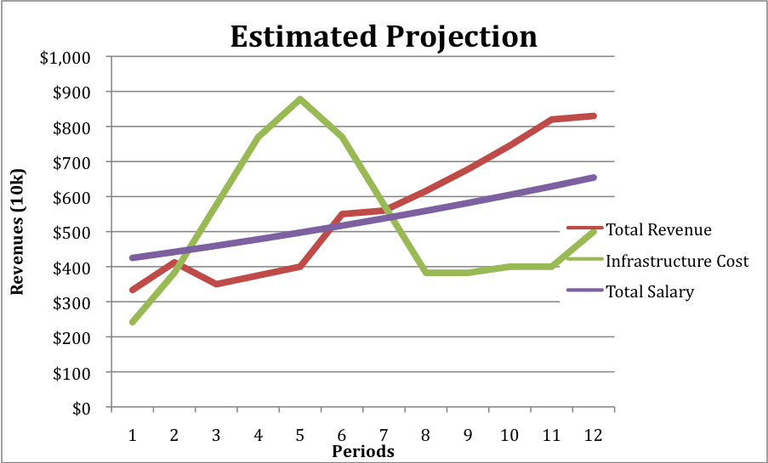

Figure1.2 Scenario 2 Estimation Data
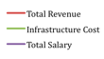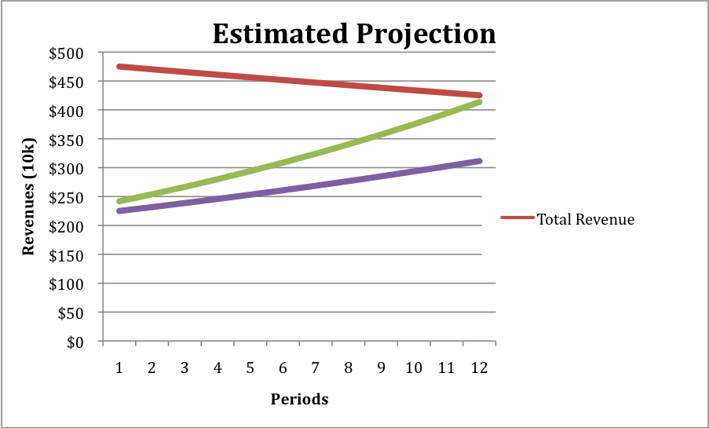

Appendix B
Figure2.1 Scenario 2 Actual Data
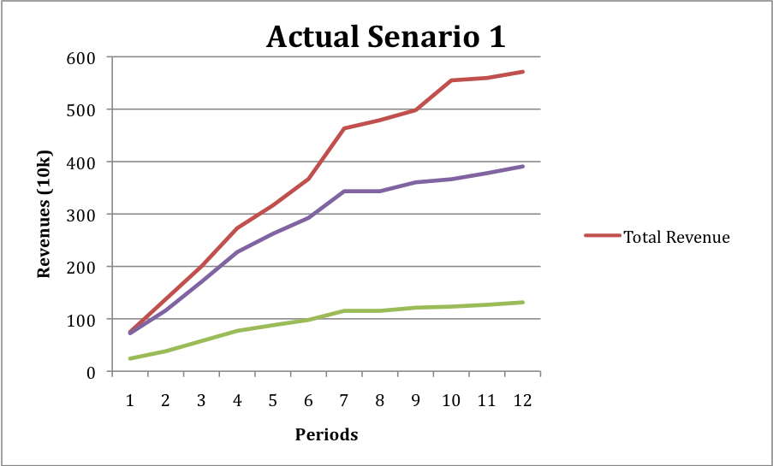
Figure2.2 Scenario 2 Actual Data
